Alaska’s National Wildlife Refuges—16 Total—Record at least one characteristic that makes each Refuge unique.
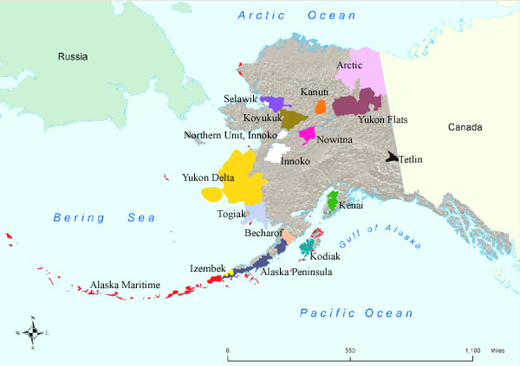
- Alaska Maritime
- Izembek
- Alaska Peninsula
- Becharof
- Kodiak
- Togiak
- Yukon Delta
- Innoko
- Nowitna
- Koyukuk
- Selawik
- Kanuti
- Yukon Flats
- Arctic National
- Tetlin
- Kenai

